**LEBANESE AMERICAN UNIVERSITY**

**USAID – HIGHER EDUCATION SCHOLARSHIP PROGRAM**

**HES - Volunteering Program Verification Form**

This form is to be used to document volunteering hours. If a student volunteers for multiple organizations, a separate form must be used for each organization. **This form must be turned in by the 28th of each month, the latest.**

I certify that the scholar Ahmad Hdeib completed a total of 5 hours of service at InnovaThrive.

The hours were completed hours as per the below:

Hours # 0 (date) _2/12 – 6/12_ (initials of supervisor) __A.K.___

Hours # 0 (date) _9/12 – 13/12_ (initials of supervisor) __A.K.___

Hours # 0 date) _16/12 – 20/12 (initials of supervisor) __A.K.___

Hours # 5 date) _23/12 - 27/12 (initials of supervisor) __A.K.___

Brief description of the activities the scholar performed or participated in:

Digital Ethics in the Age of Generative AI  
In my research on digital ethics in the context of generative AI, I explored the ethical concerns surrounding technologies like ChatGPT and DALL-E. Key issues include the ownership and copyright of AI-generated content, as well as the potential misuse of these technologies in misinformation campaigns.  
  
I examined the applications of generative AI in creative industries, such as advertising and filmmaking, and its use in education for content creation and personalized learning. Statistics showed the growing concern of AI-generated deep fakes and fake news, highlighting the risks associated with these technologies.  
  
The advantages of generative AI include the democratization of creativity, allowing more people to produce content, and cost efficiency in content production. However, ethical dilemmas around authenticity and concerns over job displacement in creative sectors were also discussed.  
  
Challenges such as implementing AI usage guidelines and ensuring transparency in AI-generated content were identified. Finally, I recommended future research to establish ethical frameworks for the responsible deployment of generative AI, ensuring its benefits are maximized while minimizing potential harm.

Written feedback about the scholar’s performance:

Ahmad’s research on digital ethics in generative AI was thorough, covering key ethical issues like copyright and misinformation. His recommendations for ethical frameworks in AI deployment were well-founded and timely.

Please rate the overall performance of the scholar at your organization:

|  |  |  |  |
| --- | --- | --- | --- |
|  | Mastery (5) | Proficient (3) | Emerging (1) |
| **Problem solver** | X |  |  |
| **Engaged & Committed** | X |  |  |
| **Open-minded & multicultural** | X |  |  |

Signature

& stamp

__________________________

_

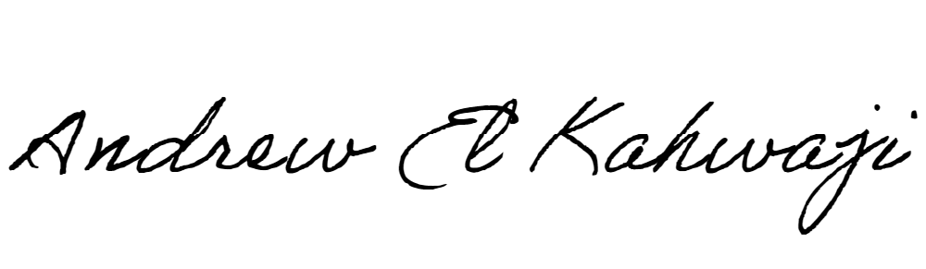

Printed Name _Andrew El Kahwaji_

Date __26/12/2024___

Email __andrew.lifesculptor.coo@gmail.com __

Phone __+961 71 914 378__